Element Résumé

Due to budget cuts, The Periodic Table of Elements Corporation is requiring all the elements to reapply for their current position on the table. Each element must provide a current résumé of their experience and accomplishments. Due to past corporate scandals, embezzlement, and general mismanagement, there are 3 upper management positions available. All elements will present themselves, and the most impressive 3 will be given the highest management positions along with an impressive bonus.

Your element will must include a résumé AND cover letter

Cover Letter - 25 points
Generally a cover letter is your first introduction to your potential employer. Your cover letter should tell the corporation that you are interested in the job and why you would be an asset to the company. You should include several pictures (at least 2) that give a quick snapshot of who you are.

Résumé - 75 points
Using the list below, The New York Times outline, and Oxygen’s example résumé, you should build your own element’s résumé. Microsoft Word has many résumé templates that can help you put the information into a professional format. Use the following list to make sure your résumé covers the basic information; use it as a check list. This list is a minimum, and any additional information about your element is encouraged. You will be able to choose any element you wish to research, however an element can only be represented once in each period. Sign up for your element with your teacher, first come first serve. You will find that certain elements have more information than others, so choose wisely! (If you want/need to change your element after beginning, you much check with your teacher and choose from the unpicked elements)

_____ element name and symbol (1 points each, 2 points total)
_____ atomic number (2 points)
_____ atomic mass (2 points)
_____ number of protons, number of neutrons, number of electrons (2 points each, 6 points total)
_____ location on the periodic table (family and period) (2 points each, 4 points total)
_____ when discovered/first produced (2 points)
_____ who discovered/who produced (2 points)
_____ where it can be currently found/how made (2 points)
_____ common compounds (references - at least 3) (3 points each, 9 points total)
_____ Physical descriptions: metal, non-metal, metalloid, color, texture, state, density, melting point,
boiling point, physical state (S, L, G) at room temperature (1 point each, 8 points total)
_____ how it is used – AT LEAST 5 common uses (1 point each, 5 points total)
_____ valence electrons (1 point)
_____ Bohr model diagram of your element (5 points)
_____ Must be in resume format (20 points)
_____ List of sources. For example, books, web sites, magazines, etc. Sources must be specific! (5 points)

Suggested Resources

- http://www.webelements.com/ interactive table
- http://www.periodicvideos.com/index.htm - interactive table of videos
- http://www.periodictable.com- interactive table, shows you what the element looks like!
- http://periodic.lanl.gov/ - interactive table
- http://www.nrc-cnrc.gc.ca/eng/education/elements/index.html - interactive table
- http://www.chemicalelements.com/ - interactive table
- www.chemicool.com/ - interactive table
- http://environmentalchemistry.com/yogi/periodic/ - interactive table, very technical
- http://chemistry.about.com/library/weekly/aa030303a.htm helps with who is credited with discovering the element, and the date of discovery
- http://chemistry.about.com/cs/howthingswork/f/blbodyelements.htm tells elements that are in the body and estimated percentages
- http://www.anachem.umu.se/cgi-bin/pointer.exe?PeriodicTables – list of website that have information on elements (check the validity of individual website sources)

The resources above are a brief list of places to start looking for information regarding your element. Be sure to check the validity and reliability of the authors of different websites. Check several websites for the same information to compare information for accuracy. Don’t simply trust the first website you check! You should individually search for specific information regarding your element by name after using the general sites listed above.
Don’t forget to give the specific web address for where you find your information!
Make copy and paste your friend for your citations!

NAME___________________________________________ DATE_____________________
Element Résumé-Building Planning Page
Directions: Research an element’s properties and history, then create a “résumé” to display them. The résumé should be concise and factual and no more than 1-2 pages. Use this planning page to collect the information you’ll display.

Heading

Element Name

Address (where is it on the Periodic Table?)

Numbers (atomic number and atomic mass)

Objective – a brief statement

What does your element want to do?

What kind of job is it looking for?

What is its ideal position? (Be creative!)

Background

How did your element get where it is now? Give a concise history.

Honors and Awards

What is your element known for?

What makes it particularly valuable for humans?

Experience and Skills

What can your element do?

What is it good at?

References

Are there other elements that could “vouch for” you element? List them here and explain their relationship.

Citations
Where did you find your information? List your sources here.

RESUME Cover Letter Example
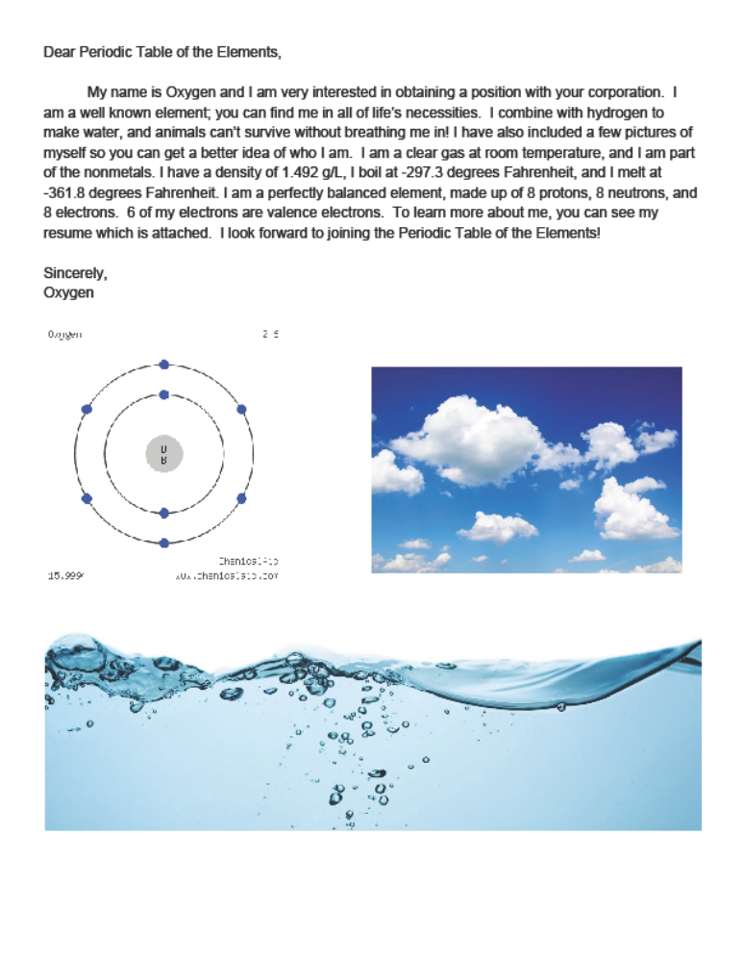

Family 16, Period 2, • Atomic #8• Atomic Mass – 15.999
Oxygen (Resume example)

Objective
I want to provide myself to living things that need to breathe me in and use me to break down their food during respiration. I am available to share electrons with other elements so that they can have a stable valence shell. My ideal position would be to pair up with hydrogen to create water. All living things need water so I feel that would be a very fulfilling job.

Background
- Discovered/named in 1774 by Joseph Priestly of England
- Given off as a product when sunlight was focused on mercuric oxide.
- Name comes from the Greek “oxy genes” which means acid-forming.

Honors & Awards
- Most abundant element in the Earth’s crust
- Second most abundant element in the atmosphere
- Candles burn more brightly in my presence

Experience & Skills
- I make breathing easier
- Key component in thousands of organic compounds
- Provide services to air-breathing organisms on land and in water
- Assist living things with breaking down their food in the respiration process
- Used in steel industry, manufacture of epoxyethane, nitric acid, hydrogen peroxide and chloroethane
- Precursor to PVC & for oxy-acetylene welding and cutting of metals
- Growing use in sewage treatment and other industry effluents

References
- Carbon - we bond in some gases and many other organic compounds like CO₂
- Hydrogen – we bond to form one of Earth’s most important molecules (water – H₂O) and to form compounds like hydrogen peroxide (H₂O₂).

Citations

- Prentice-Hall Science Explorer textbook – pages 614-615, page 632
http://www.rsc.org/periodic-table/element/8/oxygen

